## <!—Lab 1: Basic Structure of html document-->

## Output

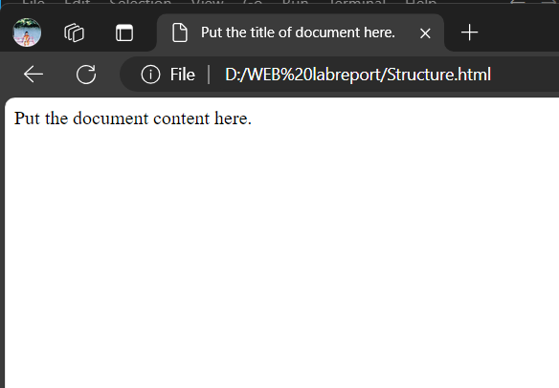

## <!--Lab 2: Working with meta tag-->

## output

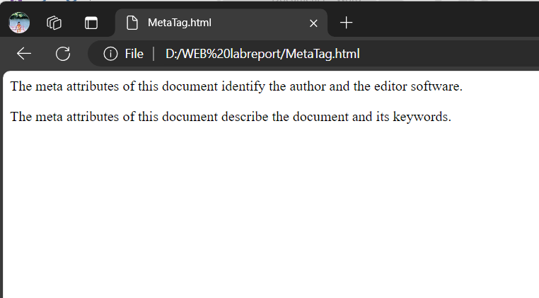

## <!--Lab 3: Redirect site to the changed address-->

## Output

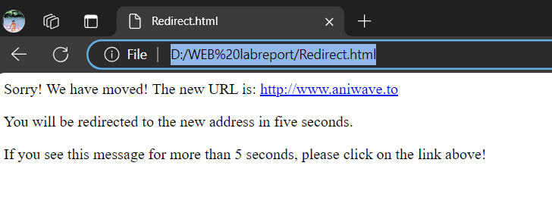

## <!--Lab 4: Working with heading tag-->

## Output

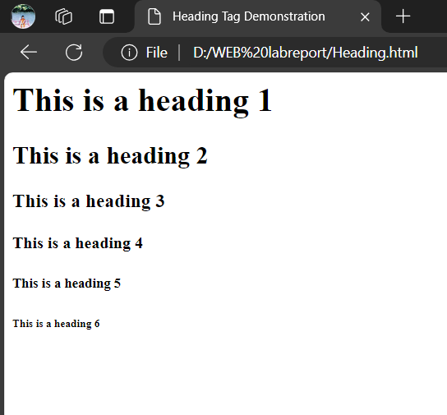

## <!--Lab 5: Working with paragraph and break tag-->

## Output

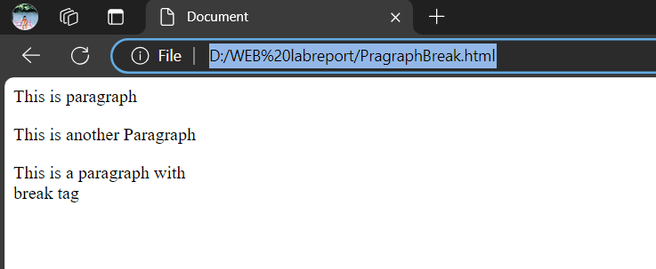

## <!--Lab 6: Working with Text formatting tags -->

## Output

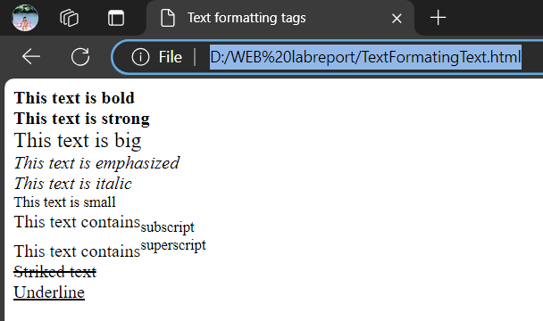

## <!--Lab 7: Working with Background and font tag-->

## Output

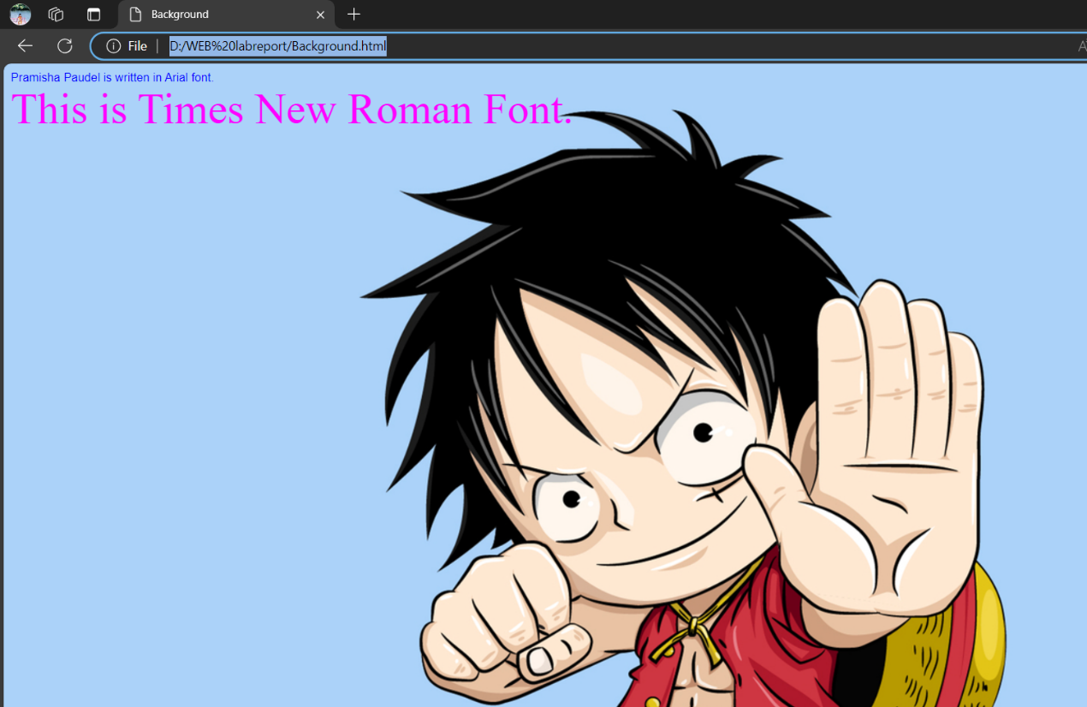

## <!--Lab 8: Formatted output-->

## Output

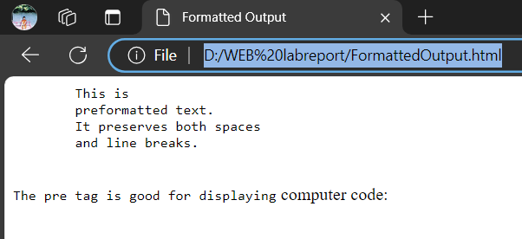

## <!--Lab 9: Working with image tag-->

## Output

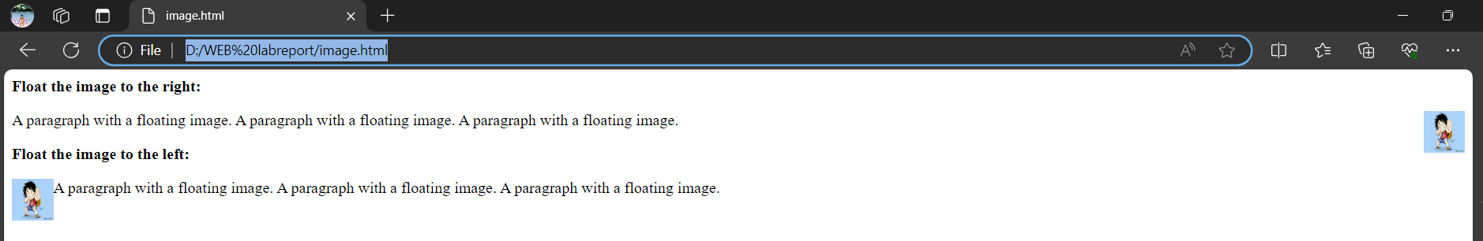

## <!--Lab 10: Working with imagemaps-->

## Output

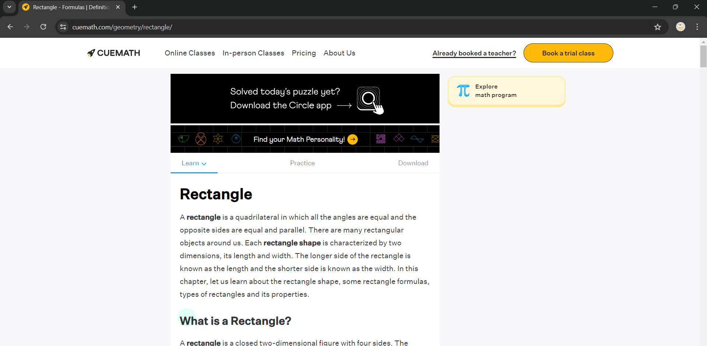

## <!--Lab 11:Using Hyperlink (anchor within page)-->

## Output

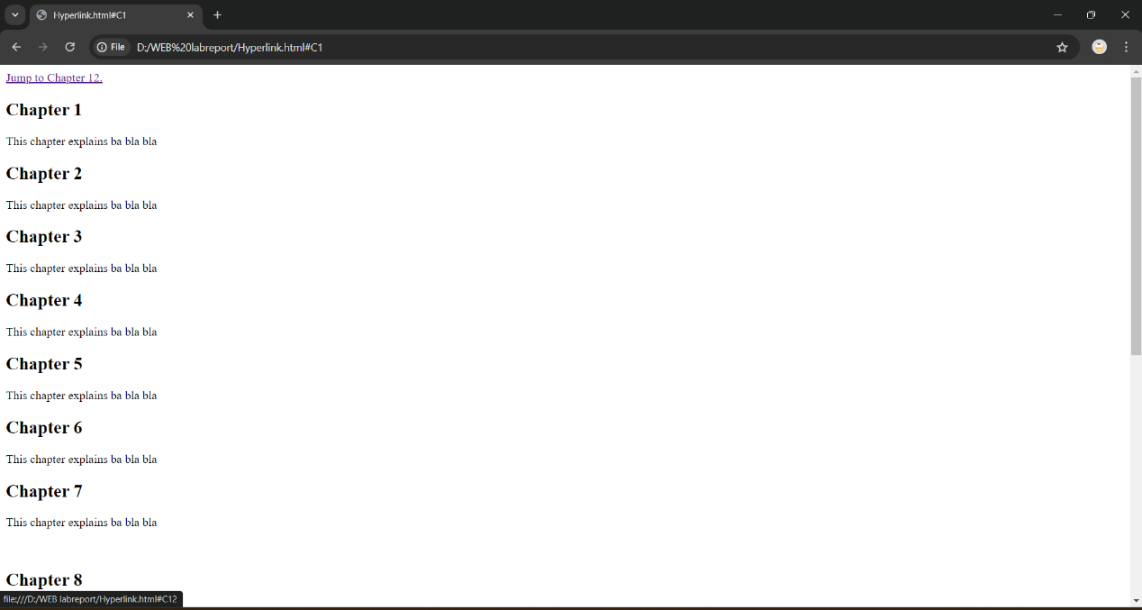

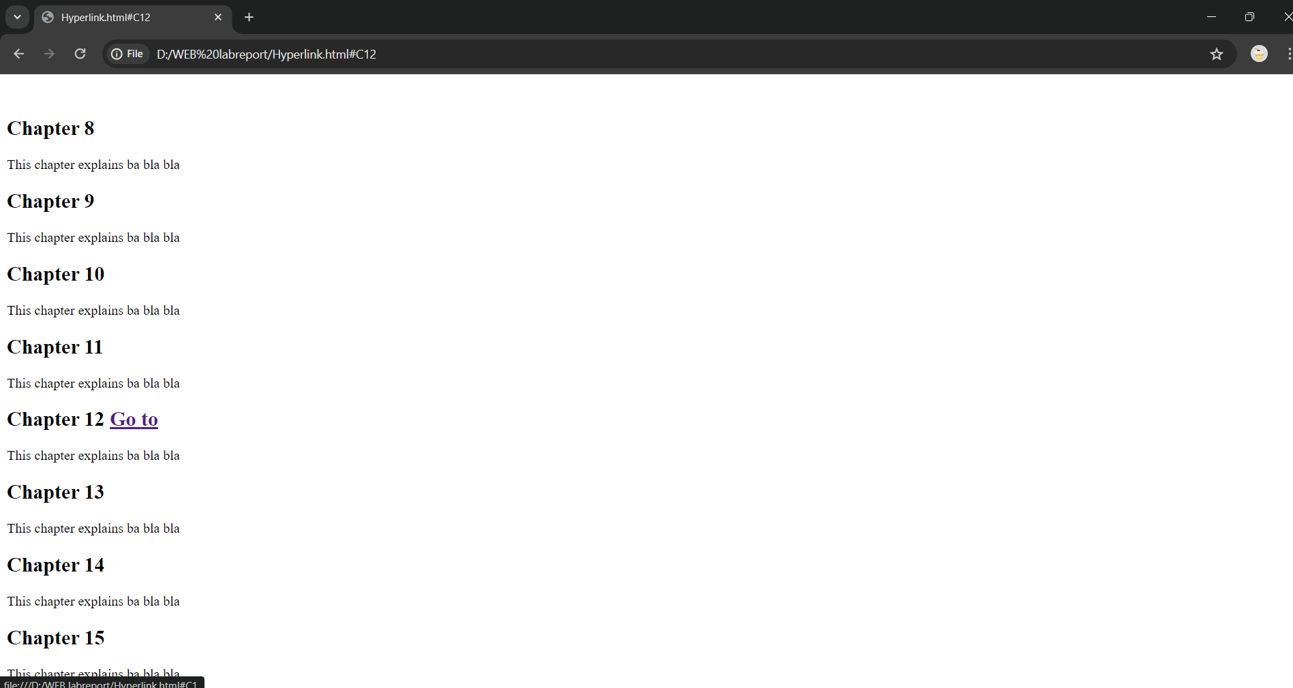

## <!--Lab 12:Using Hyperlink -->

## Output

## 

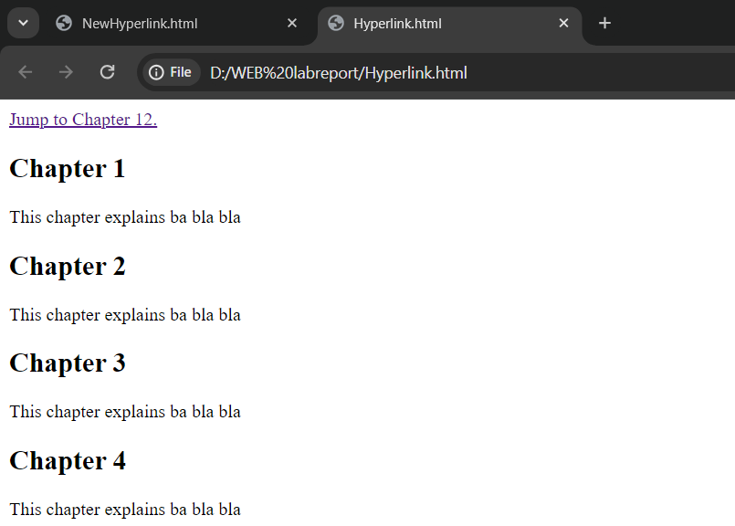

## <!--Lab 13: Working with List -->

## Output

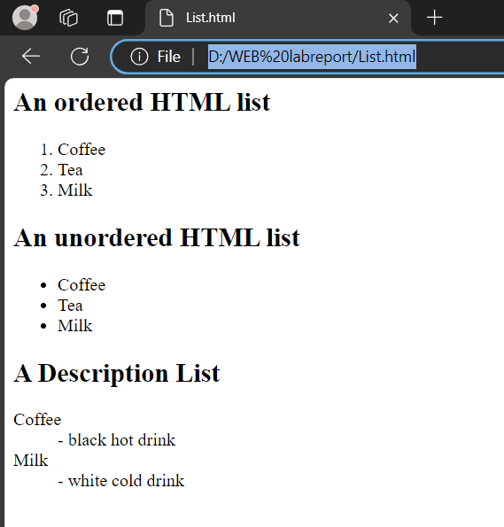

## <!--Lab 14: Working with marquee tag -->

## Output

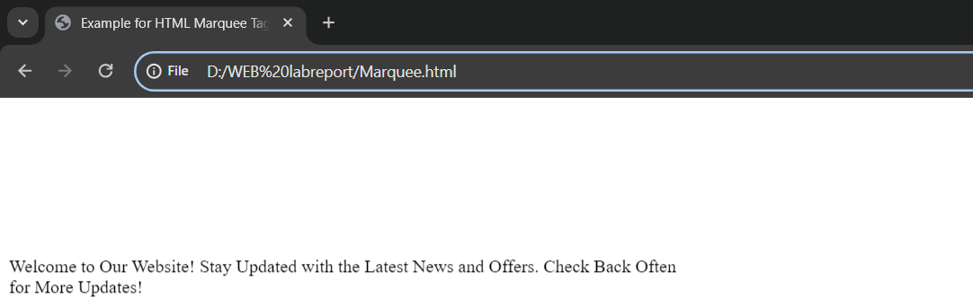

## <!--Lab 15:Working with abbr, acronym, address & dfn tag-->

## Output

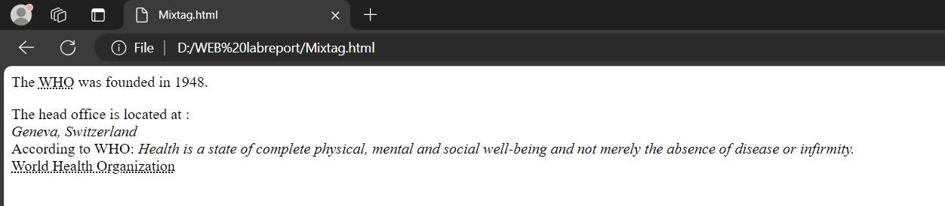

## <!--Lab 16: Creating a table-->

## Output

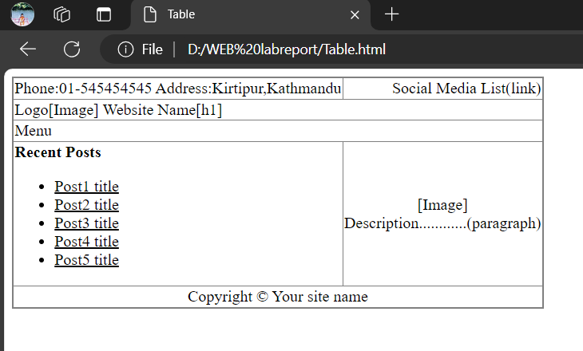

## <!--Lab 17: Creating a form -->

## Output

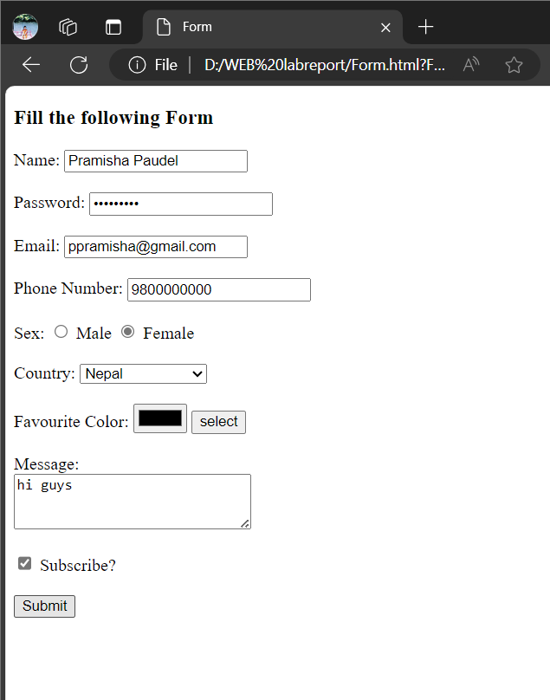

## /*Lab 1: External Style Sheet*/

## Output

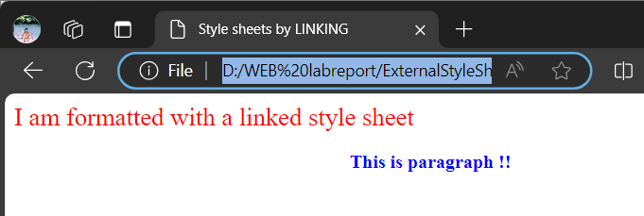

## /*Lab 2: Internal Style Sheet*/

## Output

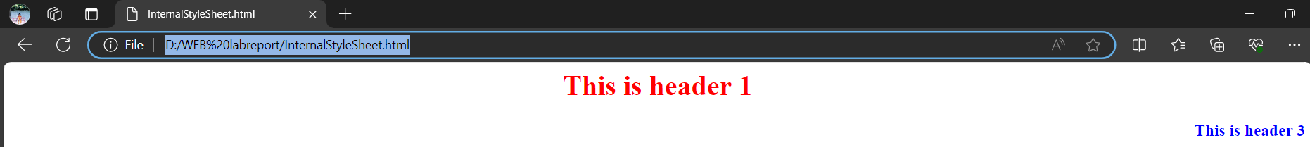

## /*Lab 3: Inline Style Sheet*/

## Output

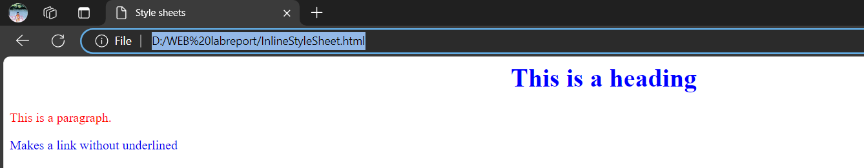

## /*Lab 4: Positioning*/

## Output

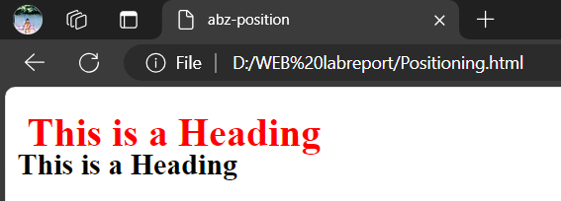

## /*Lab 5: Visibility*/

## Output

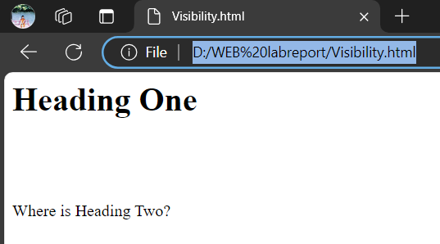

## /*Lab 6: Z-index*/

## Output

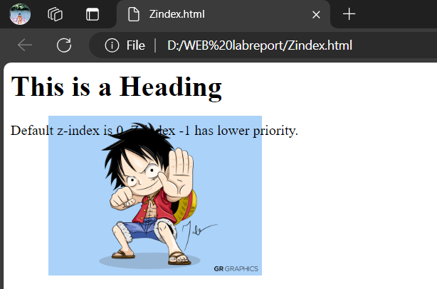

## /*Lab 7: Background using CSS with no repetition*/

## Output

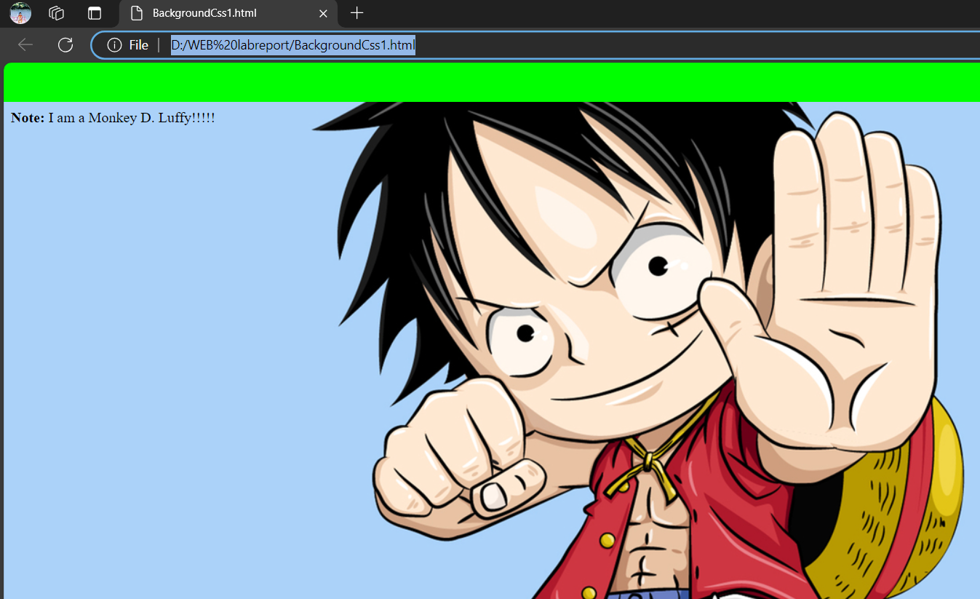

## /*Lab 8: Background using CSS where image don’t move*/

## Output

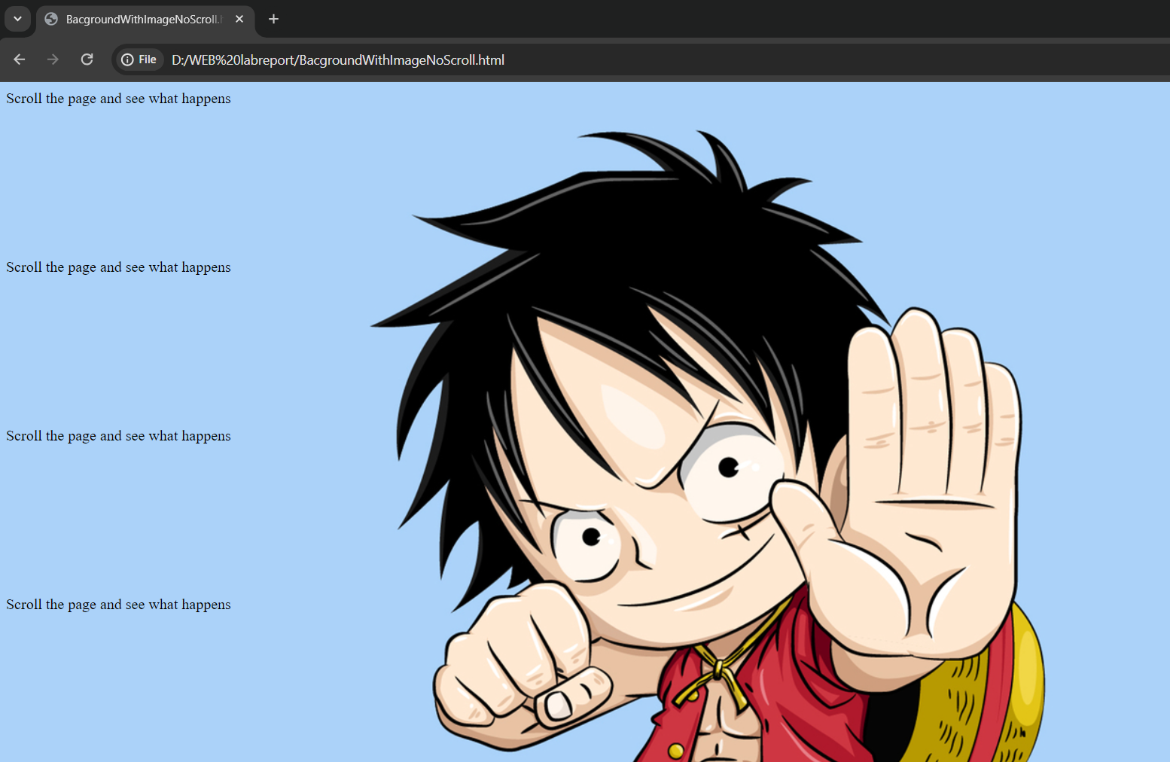

## /*Lab 9: Set background color for an element */

## Output

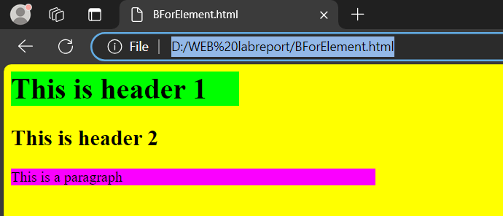

## /*Lab 10: CSS text properties */

## Output

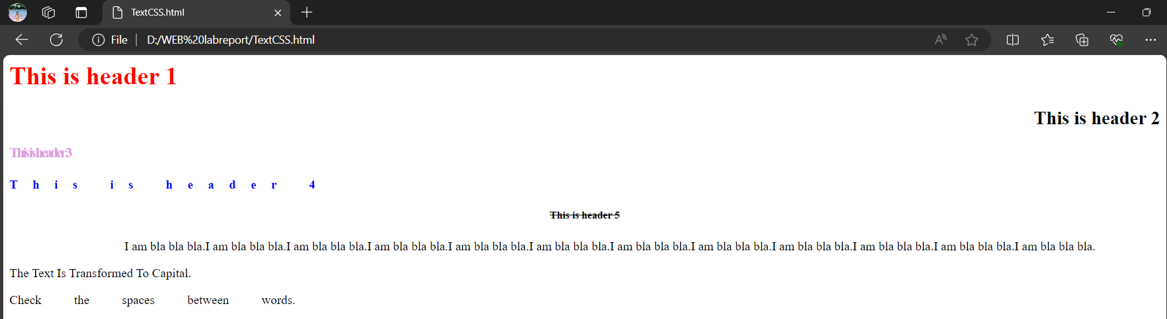

## /*Lab 11: CSS font properties */

## Output

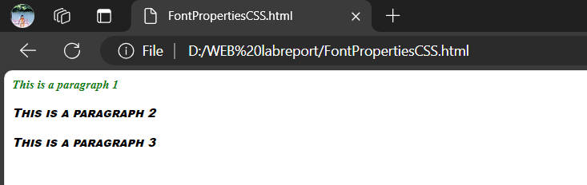

## /*Lab 12: CSS border properties */

## Output

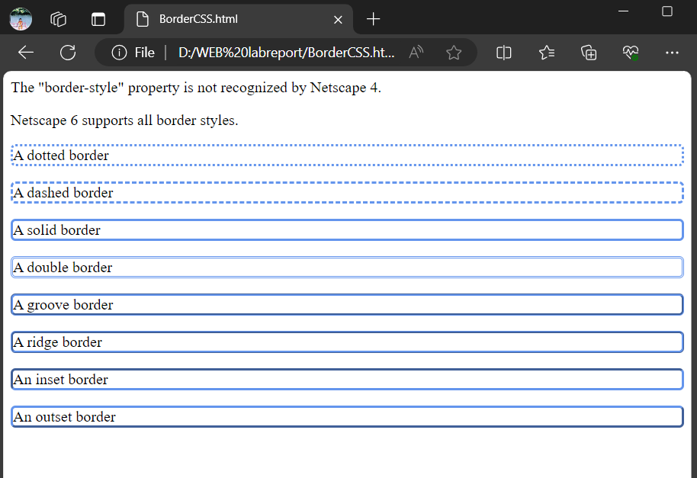

## /*Lab 13: CSS margin and padding*/

## Output

